**Docker Swarm with Replicas:**

* It will maintain or create the multiple same application containers on the multiple worker nodes.
* If any container will goes down or deleted it will automatically create the another container immediately.

**Steps to create the docker swarm with replicas:**

* First create the 3 ec2 instances one for manager or master server and another two for worker nodes.
* Install the docker on these 3 instances.
* Initialize the docker swarm by using **docker swarm init** command on manager or master server.
* It will generate the token.copy this token and paste it on 2 worker nodes.
* Create the service by using **docker service create --name service name --replicas no.of replicas --publish portno(we can give any port no whatever we want):imageportno image name** command on manager server.It will create the containers automatically.

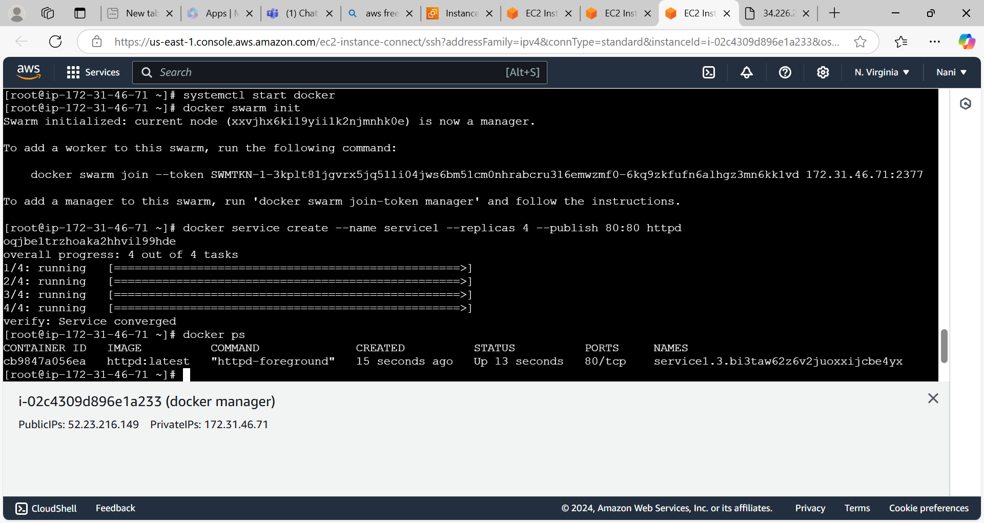

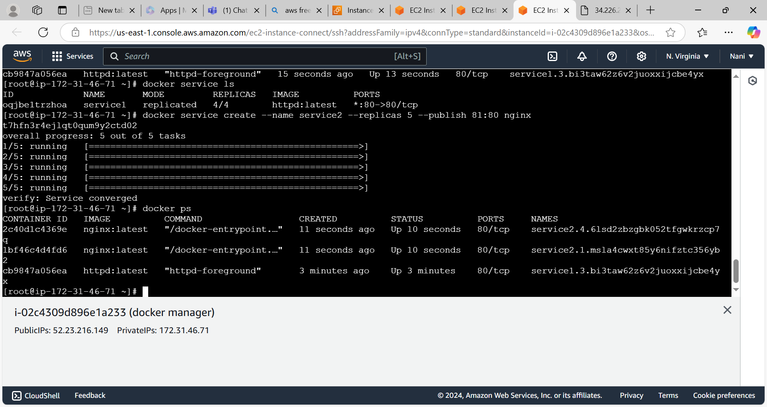

* Above command I have given the replicas as 4 so it will create the 4 containers.one container is created on master and another containers are created on multiple worker nodes like below image.

Worker node1

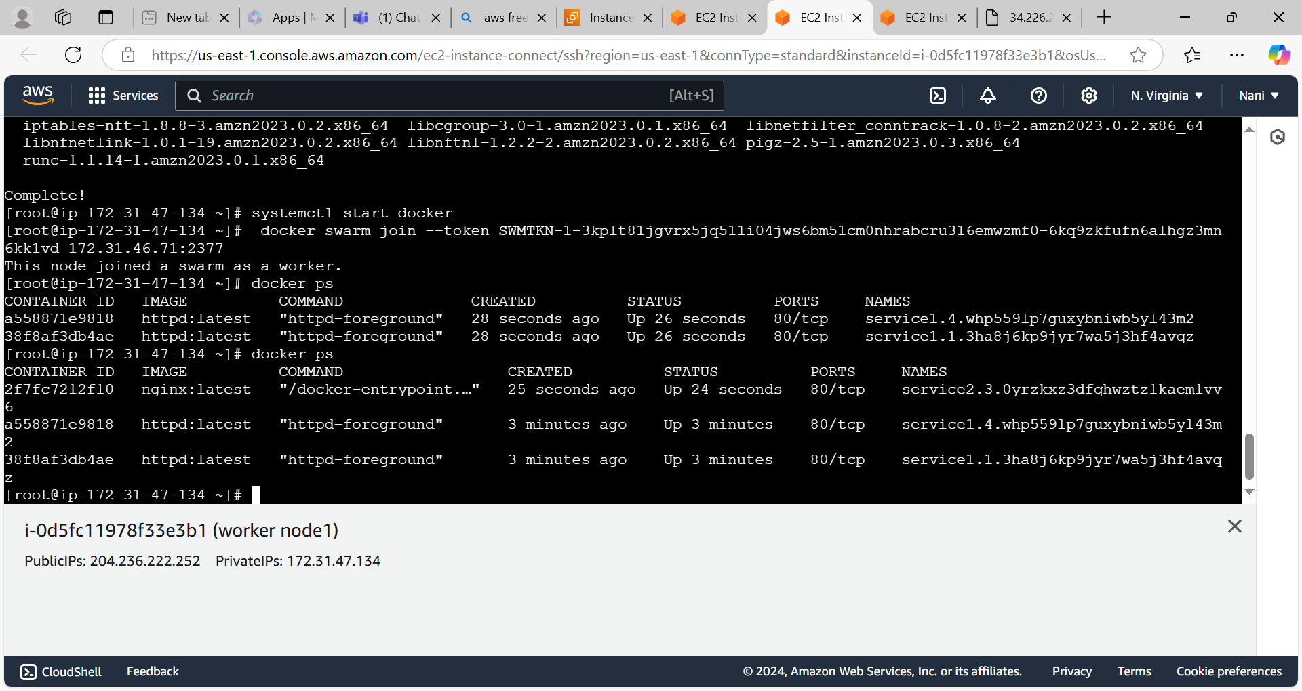

Worker node2

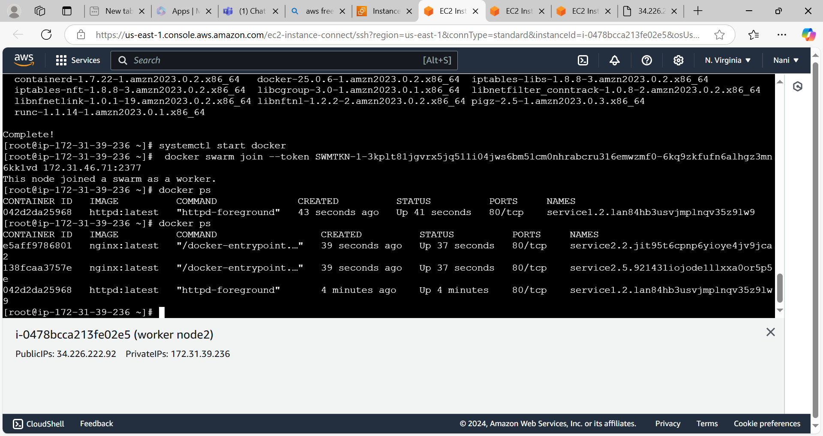

* Access the nginx application

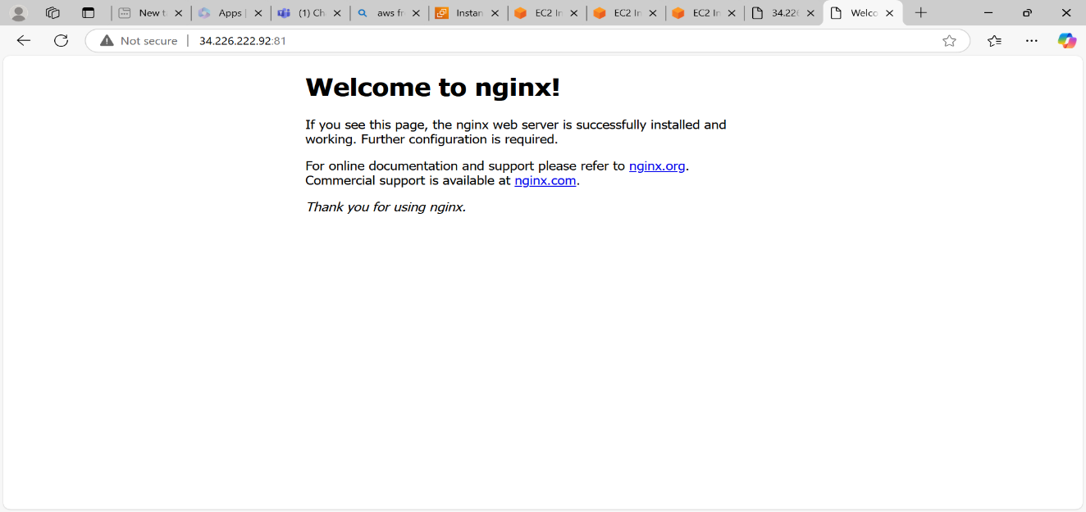

* Access the httpd application

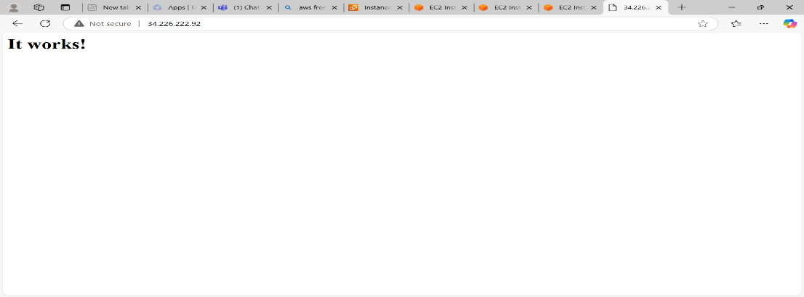

* We can create the replicas by using the custom image by using the docker file.
* Write the docker file by using **vi Dockerfile** command on manager server.

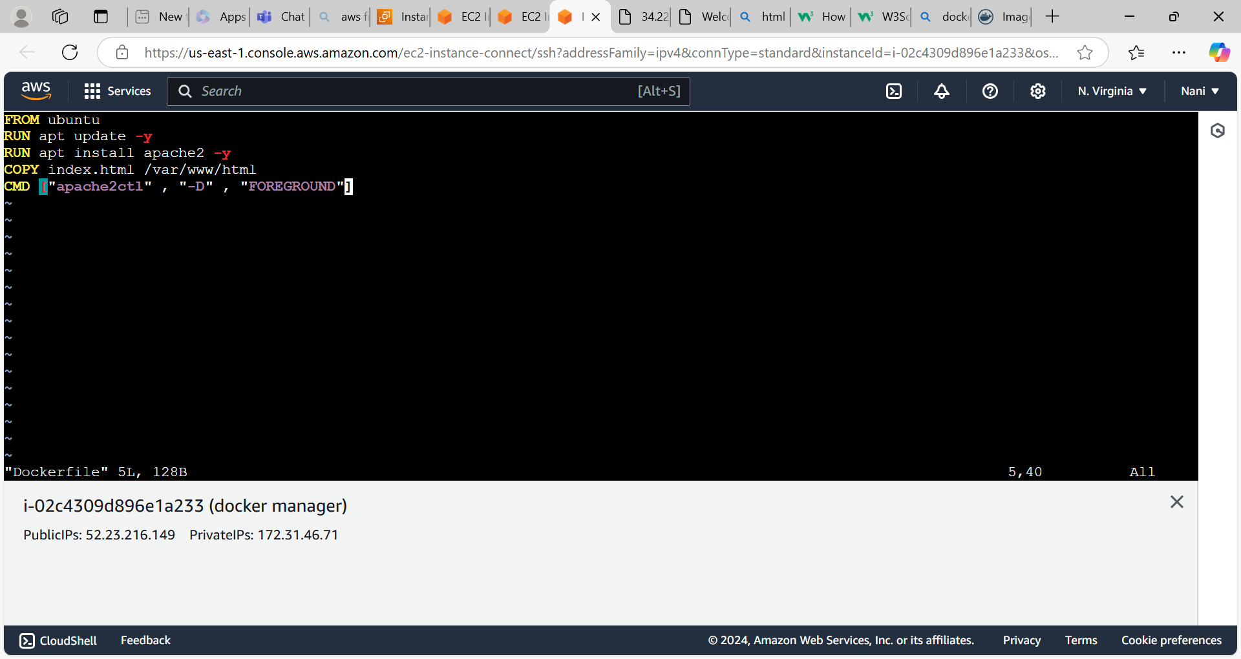

* Build the image by using **docker build -t image name .** command.

and create the service by using docker cli command.

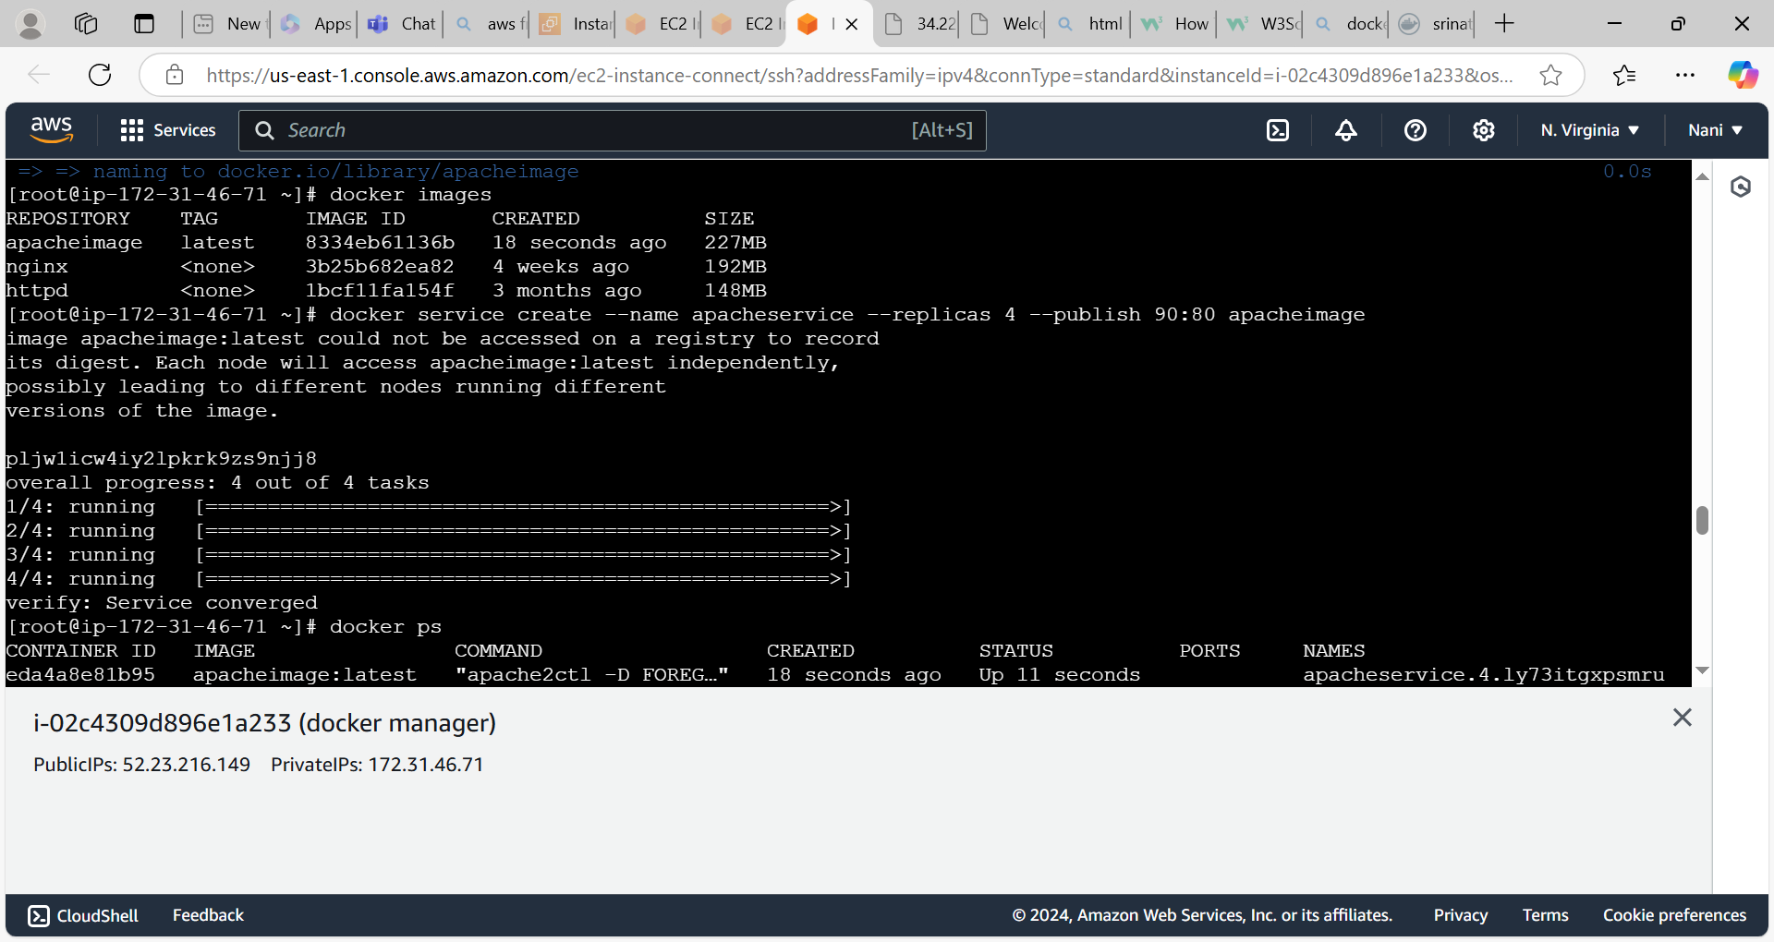

* All apacheservice related containers are running on master or manager server.

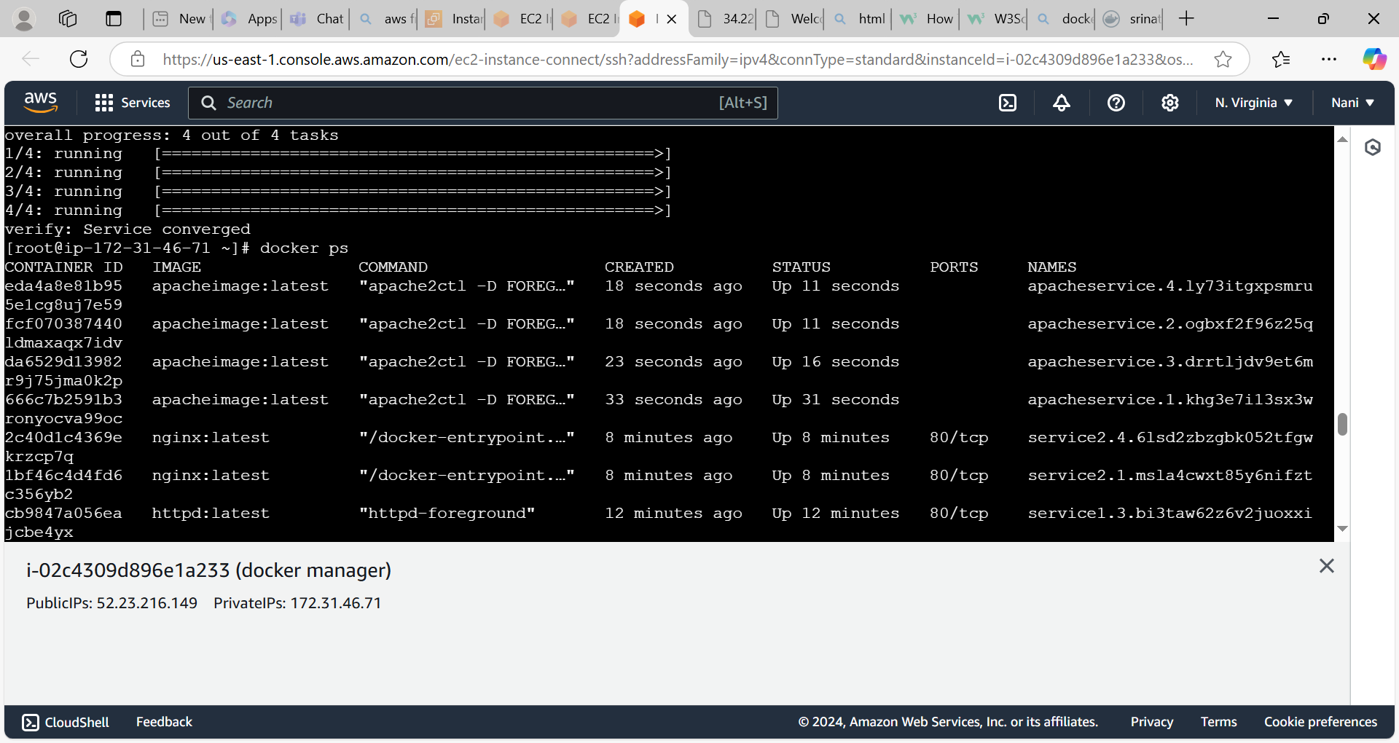

* Access the html login page

